- Identify and Explain different types of holding tools used in wood
- Draw and label the parts of bench vices Wood

RATIONALE
Knowledge: Vices, uses and safety predations when using holding tools
Skills: Application off correct holding of tools when you wasting materials Values: Appreciations of holding tools when working with materials TEACHING AIDS: Bench vices, hand vices Clamps, pliers
PART | LESSON CONTENT | METHOD OLOGY | LEARNER ACTIVITY
introdu ction | - Recap on the previous lesson | Q/A | Provide answers
Development | HOLDING TOOLS  Wood  Wood bench vice this is used to hold wood and metal for filing, sawing, chiselling and tapping  - A bench hook is a woodworking accessory that enables a piece of wood to be held firmly in position on a workbench while it is cut.  - Clamps are used to hold work piece at right angle while gluing and pining  Types of clamps  - Sash clamp: This is a large clamp used for holding and drawing parts of a work piece together while gluing  - G-clamp. This is a metal clamp used for holding a work piece while sawing or chiselling.  - Bench Holdfast is used to hold job firmly on the bench when moulding and rebating  FOUR CATEGORIES VICE  - Metalworking, vice  - Woodworking, vice  - Hand-held vice  - Machine vice  WOODWORK BENCH VICE  - Mounted underneath a workbench  PARTS OF THE WOOD BENCH VICES  .
Application | CLASS EXERCISE  - What are holding devices used for?  - List three examples of clamps.  - What is the function of a bench holdfast?  - What is the function of a bench hook? | Questions And Answers | Provide answers
Conclus ion | - Recap on the main steps and points | V/E

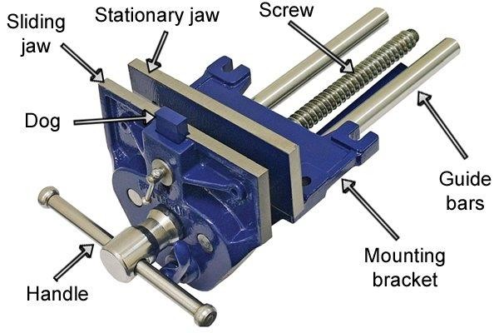

- Identify and Explain different types of holding tools used in metal
- Draw and label the parts of bench vices Metal vices )

RATIONALE
Knowledge: Vices, uses and safety predations when using holding tools
Skills: Application off correct holding of tools when you wasting materials Values: Appreciations of holding tools when working with materials TEACHING AIDS: Bench vices, hand vices Clamps, pliers
PART | LESSON CONTENT |  |  |  | METHO DOLOG Y | LEARNER ACTIVITY
introdu ction | - Recap on the previous lesson |  |  |  | Q/A | Provide answers
Development | HOLDING TOOLS (Metal)  Hand Vice:  - Unlike the bench vice, the hand vice is not fixed to anything. It is held by the hand.  - The hand vice is used for holding small work pieces that cannot be handled conveniently by the bench  Machine Vice:  - Machine vice looks like a bench vice.  - The machine vice is commonly used on drilling, milling and shaping machines.  Pliers  - Holding devices held in the hand of users.  - It is used for gripping and cutting wires and thin metal sheets.  Types of pliers  - Long nose pliers = used for holding flat metals in jobs where they are desirable or awkward places  - Cutting pliers= for cutting  - Combination pliers= used for holding both flat and round metals, for cutting light-in-thickness or diameter metals  - Flat-nose pliers are used for holding flat metals in a  - Round-nose pliers= used for holding workpieces with holes  Leg Vice  - Used by blacksmiths. It is used for holding workpieces that require heavy blows to bend  More grip BENCH VICE  PARTS OF THE METAL BENCH VICE
Development |  |  | BENCH VICE  - It is fastened to the bench, near its edge, with bolts and nuts.  - Used for all types of heavy work, like filing, chipping and sawing.  - The bench vice has two separated jaws that ensure a firm grip on a workpieces.  - However, finished surfaces must be protected from direct contact with the separated jaws, to prevent marks on them
Application | CLASS EXERCISE  - What are pliers?  - Mention four examples of pliers.  - What is the difference between bench vice and hand vice |  |  |  | Questions And Answers | Provide answers
Conclus ion | - Recap on the main steps and points |  |  |  | V/E

